ATLS 3519 Final Project | Peter Gailitis
  - Spohn Performance Website Redesign

Final Project Proposal

Site Selected and Description
Website URL: https://www.spohn.net/
The site I plan to redesign is the Spohn Performance website. Spohn Performance is a performance automotive parts manufacturer and online retailer that sells suspension, chassis, and drivetrain components for a wide range of vehicles, including GM, Ford, Ram, and Jeep models. The company was founded in 1999 and operates from Myerstown, Pennsylvania. The website includes a large product catalog, vehicle-specific categories, customer accounts, a shopping cart, support resources, customer vehicle galleries, videos, and company information. Although the site provides access to many specialized and useful products, its current presentation feels outdated and crowded. The large number of navigation choices, competing page elements, small text, and weak visual hierarchy make the site harder to scan and use than it needs to be.

Why I Chose This Site
I chose this site because I recently had to use it while rebuilding my grandfather’s 1988 Avanti, which had been sitting in a garage for approximately 25 years. Spohn Performance sells strong aftermarket parts that can be useful for a project like this, but the website makes finding and comparing those parts more difficult. I have encountered many poorly designed websites, and this one stood out since the quality of the products is better than the quality of the online shopping experience. A redesign would allow me to keep the company’s useful catalog while improving organization, readability, navigation, accessibility, and the overall appearance of the site. The project also has a personal connection because the vehicle restoration gave me a real reason to use the website rather than selecting a site only for the assignment.

Site Owner and Contact Status
Spohn Performance is owned and operated by Steven J. Spohn and is described as a family-run company. Steven J. Spohn is listed as the company president. I have attempted to make contact regarding a possible interview, but I have not received a response, so I am not currently expecting that an owner interview will be available for the project. I may still email the company a picture or mockup of the completed redesign and explain the main usability and accessibility improvements. I may also include a photograph of the finished Avanti restoration to show the real project that led me to their products and to request any feedback they are willing to provide.

Final Project First Draft
Website URL: https://www.spohn.net/

Brief Description of the Business
Spohn Performance is a family-operated performance automotive manufacturer and online retailer based in Myerstown, Pennsylvania. The company designs and sells suspension, chassis, and drivetrain components for muscle cars, trucks, Jeeps, street rods, and other performance vehicles. Its catalog is organized mainly by manufacturer, model generation, production years, and vehicle platform. The website also provides a support center, customer vehicle gallery, videos, company information, account tools, and online checkout. This is a specialized business whose customers may need to verify exact vehicle fitment before purchasing relatively expensive mechanical components. For that reason, the site must make product categories, compatibility, technical information, support, and purchasing steps especially clear. The current website contains useful products and a large amount of information, but much of that value is hidden by a crowded interface and an outdated browsing structure.

Planned Interviewees
The first planned interviewee is Steven J. Spohn or another Spohn Performance employee who understands the company’s products, customer questions, and current website. I have attempted to contact the company but have not received a response. I will document the contact attempt and use any response that arrives before the final deadline. If the owner is unavailable, I will try to contact a customer-service or technical-support representative instead.
The user interview will involve a person who has experience shopping for automotive repair or performance parts online. I will ask that person to locate a compatible suspension component, identify the relevant technical information, and explain what would make the site feel trustworthy and easy to purchase from. A second informal observation may involve a person who is unfamiliar with Spohn Performance so I can compare expert and first-time navigation. The interviews will focus on actual tasks and open-ended follow-up questions rather than only asking whether the participants like the visual design.

Project Goal
The goal is to redesign the Spohn Performance shopping experience so customers can quickly understand the company, select their vehicle, find compatible parts, compare products, and reach technical support. The redesign will preserve the company’s established products and automotive identity while replacing the crowded page structure with a clearer visual hierarchy and more predictable navigation. The proposed design will emphasize accessibility, responsive behavior, semantic HTML, and efficient product discovery.
- Create a simplified header with a prominent product search, account access, cart status, and support link.
- Add a clear “Shop by Year, Make, and Model” path so users do not have to remember platform names before browsing.
- Organize product categories into manageable menus instead of displaying the entire catalog hierarchy at once.
- Use a meaningful H1, logical headings, descriptive links, readable typography, and sufficient contrast.
- Redesign product cards so the image, product name, vehicle fitment, price, and primary action are grouped together.
- Provide complete keyboard access, visible focus indicators, useful alternative text, and properly labeled forms.
- Make technical support, compatibility guidance, shipping information, and return policies easy to locate before checkout.

Heuristic Evaluation of the Current Site
The current homepage was reviewed using common usability and accessibility heuristics. Severity is described as Major when the issue can prevent or strongly discourage task completion, Moderate when it creates delay or confusion, and Minor when it mainly affects polish or consistency. The evaluation includes strengths as well as problems that should guide the redesign.

WAVE Accessibility Evaluation Results
The WAVE evaluation yielded the following results for the current Spohn Performance homepage. These findings are incorporated into the heuristic evaluation below. Due to a formatting error I cannot figure out, the header below re-appears though it should not. A purposeful formatting technique used below was to shrink the size of certain text boxes’ text as to not have them run for multiple pages.
WAVE Category |  | Result from Current-Site Evaluation
Overall WAVE result |  | 40 errors, 32 contrast errors, 141 alerts, 26 features, 10 structural elements, and 5 ARIA items
AIM score |  | 2.3 out of 10
Linked images |  | 3 linked images missing alternative text
Forms |  | 1 missing form label
Document language |  | 1 missing or invalid language declaration
Links |  | 35 empty links
Heading structure |  | Only one heading was detected: H3 “Hot New Products”; no useful H1/H2 hierarchy was shown
Navigation order |  | The Order view shows a long sequence of header, account, search, catalog, product, and social links before and around the main content
Heuristic / Severity | Current-Site Finding | Necessary Correction
1. Clear page purpose and hierarchy — Major | The homepage opens with several utility areas, navigation rows, search controls, category links, and promotional graphics before presenting a clear page-level message. The company purpose is explained in body text, but there is no strong, prominent H1 that immediately identifies the page and its primary task. WAVE's Structure view detected only one heading on the page: an H3 labeled “Hot New Products,” with no meaningful H1 or H2 structure. | Add one descriptive H1 and a short value statement near the top, followed by logically nested H2 and H3 headings. Visually prioritize vehicle and product discovery over secondary promotions.
2. Information architecture — Major | A very long nested list of vehicle generations and product groups is exposed in the left column. Users must scan dozens of options, and the list mixes manufacturers, body platforms, date ranges, services, and replacement parts at the same level. | Use progressive disclosure: begin with vehicle make or a year/make/model selector, then reveal only relevant models and categories. Separate services and general parts from vehicle browsing.
3. Match with the user’s mental model — Major | The catalog relies heavily on terms such as F-Body, G-Body, A-Body, and platform-year combinations. Experienced customers may understand them, but a first-time owner may know only the vehicle year, make, and model. | Let users start with familiar vehicle information. Platform terminology can appear as supporting information after the vehicle is selected.
4. Recognition rather than recall — Major | Customers must remember which platform or generation matches their vehicle before selecting a category. The homepage does not provide obvious fitment guidance or a vehicle saved to the session. | Add a persistent vehicle selector, fitment confirmation, and a “My Vehicle” area. Show compatible categories after selection.
5. Navigation clarity — Moderate | The header contains a shipping message, brand area, live help, shop tour, cart controls, a long utility menu, account information, and search. These competing rows weaken the distinction between primary shopping navigation and secondary company links. | Use one compact utility bar and one primary navigation row. Group About, Customer Cars, Blog, and social content under secondary navigation or the footer.
6. Visibility of system status — Moderate | The cart item count and subtotal are visible, which is useful. However, search, chat availability, and category selection do not provide an equally clear sense of state from the homepage. | Keep the useful cart status. Add clear search result feedback, selected-vehicle status, loading indicators, and explicit online/offline chat status.
7. Search design — Major | The search area is visually small compared with the size of the catalog, and its wording combines “Search Products,” “Site,” and “Go” in a way that is less clear than a modern labeled search control. WAVE also reported one missing form label, indicating that at least one control does not have a properly associated accessible label. | Use a prominent search field with a persistent programmatically associated label, useful placeholder example, search button, spelling tolerance, and suggestions by product, vehicle, or part number.
8. Consistency and standards — Moderate | The page mixes image links, plain text links, utility controls, and category links with different visual treatments. Similar destinations are named differently in different areas, such as Contact versus Contact Us. WAVE also reported that the page language was missing or invalid, which can cause a screen reader to use the wrong pronunciation rules. | Standardize labels, button styles, link treatments, spacing, and naming. Use familiar shopping patterns for search, cart, filters, and product actions, and set a valid language attribute on the HTML element.
9. Aesthetic and minimalist design — Major | Many elements compete for attention at the same time: the complete category tree, newsletter sign-up, review graphic, membership information, carousel, support and social graphics, and a large product list. This makes the page feel dense even though much of the content is useful. | Prioritize the most common tasks and move secondary material lower on the page. Replace multiple promotional graphics with a focused introduction, key categories, and selected products.
10. Readability and scanning — Major | The design uses dense link lists, long product names, small supporting text, and limited spacing. Important information is difficult to distinguish quickly, especially for users with low vision, attention limitations, or a small display. WAVE identified 32 contrast errors across the evaluated homepage. | Increase base font size, line height, spacing, and heading contrast. Break long names into product name, fitment, and feature lines. Maintain readable line lengths and verify that text and interface controls meet WCAG contrast requirements.
11. Link purpose — Moderate | The homepage repeats vague link treatments and includes many linked graphics. WAVE reported 35 empty links, meaning those links do not provide an accessible name or readable purpose to a screen-reader user. | Remove links that have no destination or content. Give every remaining link a descriptive accessible name, such as “View tubular rear control arms,” and make the descriptive product title the primary link.
12. Images and alternative text — Moderate | Product and promotional images are heavily used throughout the page. WAVE reported three linked images missing alternative text, so a screen reader may announce only an unlabeled link or file information instead of the destination or image purpose. | Write concise alternative text for informative graphics, use empty alt text for decorative images, and give every linked image an accessible name that describes its destination.
13. Keyboard and screen-reader efficiency — Major | The exposed catalog and utility areas create a very long sequence of links and controls before and around the main product content. WAVE's Order view confirms a lengthy navigation sequence, while the overall report found 40 errors, 141 alerts, only 10 identified structural elements, and 5 ARIA items. Even when controls are technically reachable, empty links and weak headings make keyboard and screen-reader navigation inefficient. | Add a working skip link, semantic header, nav, main, and footer landmarks, collapsible accessible menus, logical headings, and a concise default navigation state. Remove empty links and test focus order, accessible names, and visible focus throughout.
14. Product presentation and comparison — Moderate | Hot products are presented with long titles, images, and repeated calls to action, but important shopping details such as price, fitment summary, key differences, and availability are not emphasized together on the homepage. | Use consistent product cards that group name, vehicle compatibility, price, stock status, rating if available, and one clear action. Add filters and comparison tools on listing pages.
15. Error prevention and recovery — Moderate | Because compatibility depends on precise vehicle information, selecting the wrong category can lead to an incorrect and costly purchase. The homepage provides categories but no obvious confirmation that a part fits the user’s vehicle. | Require or encourage vehicle selection, display a clear fitment confirmation, warn when fitment is uncertain, and provide helpful recovery paths instead of generic error messages.
16. Help and documentation — Minor/Moderate | The site provides a Support Center, FAQs, live help, phone assistance, and a shop tour, which are valuable strengths. However, these resources are distributed across several areas and may not appear at the point where a customer has a fitment question. | Keep these support options but consolidate them under a clear Help area. Place contextual fitment and installation help beside relevant products and checkout steps.
17. User control and freedom — Moderate | The number of categories and promotional destinations can pull users away from the shopping task. The homepage does not provide an obvious way to save a vehicle, recently viewed product, or comparison state and return later. | Support breadcrumbs, recently viewed products, saved vehicles, wish lists, and clear back/cancel actions without losing the user’s place.
18. Responsive and touch use — Moderate | The desktop homepage contains multiple horizontal header rows and a long sidebar. Simply stacking these elements on a smaller screen would create excessive scrolling and small touch targets. | Design mobile navigation intentionally, use large touch targets, collapse secondary links, keep search and cart easy to reach, and test the layout at common breakpoints.
Wireframe of the Current Home Page
Website URL: https://www.spohn.net/
The following low-fidelity wireframe was created digitally from the current desktop homepage. It records the existing content hierarchy and layout rather than showing the planned redesign.
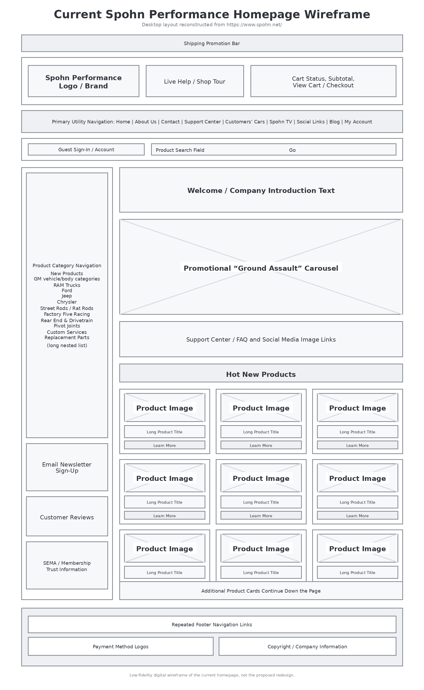
Figure 1. Current Spohn Performance homepage wireframe.

Site Map of the Current Site
Website URL: https://www.spohn.net/
Site Map URL: https://www.gloomaps.com/tqCtTWY7JG
The following visual site map records the current Spohn Performance website structure. It is limited as per Part 1 instructions. Product model-year pages and individual articles continue beyond the depth shown here and will be completed for the final submission.
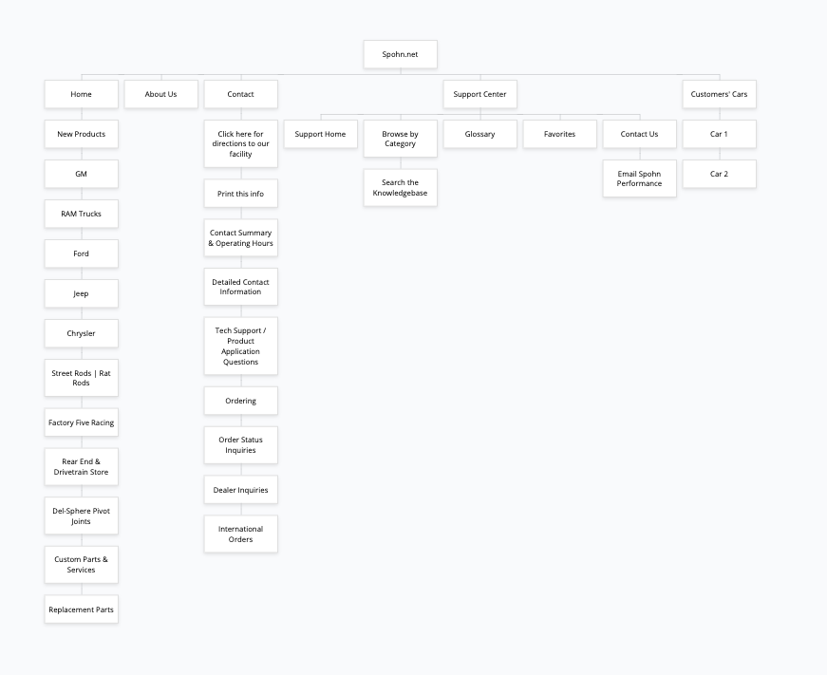
Figure 2. Current Spohn Performance website site map.

Final Project Second Draft
Website URL: https://www.spohn.net/

Updates from the First Draft
The proposal and first-draft sections above remain unchanged. This second draft adds a proposed information architecture, three wireframes for the redesigned site, two persona profiles with justification, and two coded prototype pages. The new design responds to the earlier heuristic and WAVE findings by reducing the number of competing navigation choices, giving vehicle selection and product search priority, establishing a useful heading hierarchy, consolidating support information, and using labeled controls, semantic page regions, descriptive links, visible keyboard focus, and responsive layouts.

GitHub: https://github.com/obsanity-live/ATLS3519-640F/tree/ff820f6eb7e03c4e46324b91a9573d6bdfd91bce/ATLS3519-640F%20FINAL%20PROJECT%20%7C%20Gailitis

Site Map of the Redesigned Site
Website URL: https://www.spohn.net/
The proposed site map limits the home page to five primary branches and shows the redesigned structure up to three levels down. The structure gives product discovery the strongest position while keeping technical help, company information, community content, and account functions available without exposing the entire catalog at once.
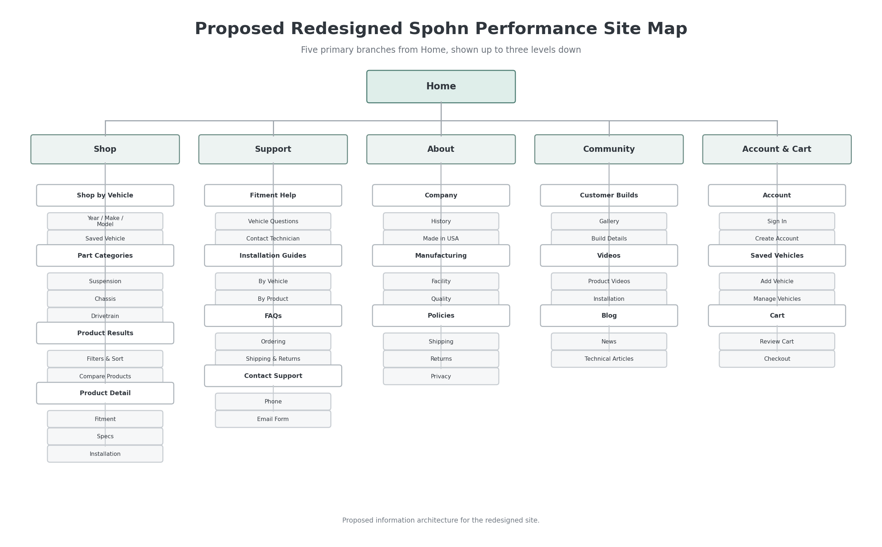
Figure 3. Proposed site map for the redesigned Spohn Performance website.

Wireframes of the Redesigned Site
The following low-fidelity wireframes show the redesigned home page and two subpages. They preserve the company’s automotive identity while reorganizing content around vehicle fitment, product discovery, readable information, and accessible interaction.

Redesigned Home Page
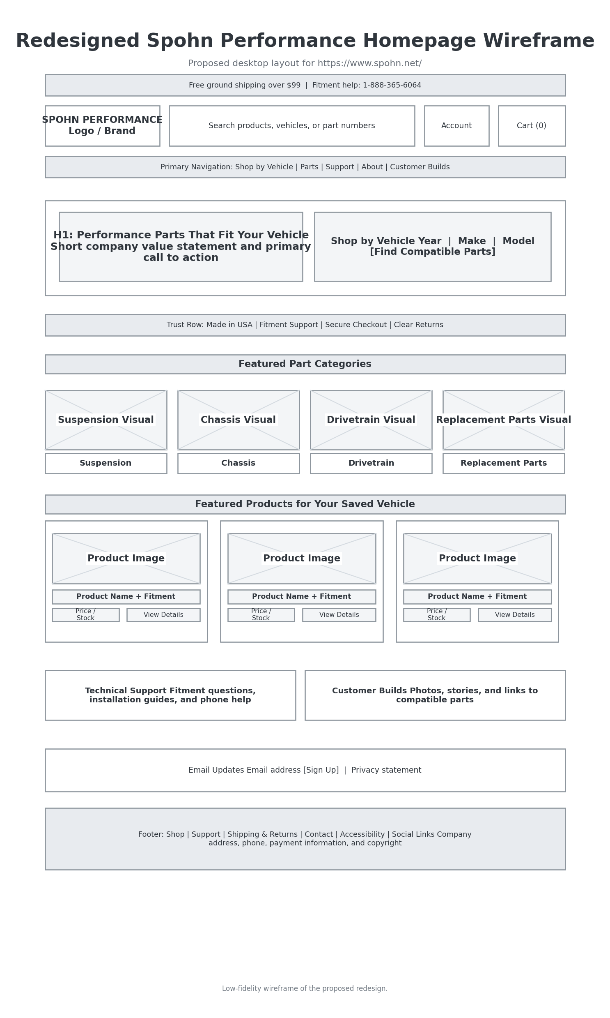
Figure 4. Proposed redesigned home page wireframe.

Redesigned Product Results Page
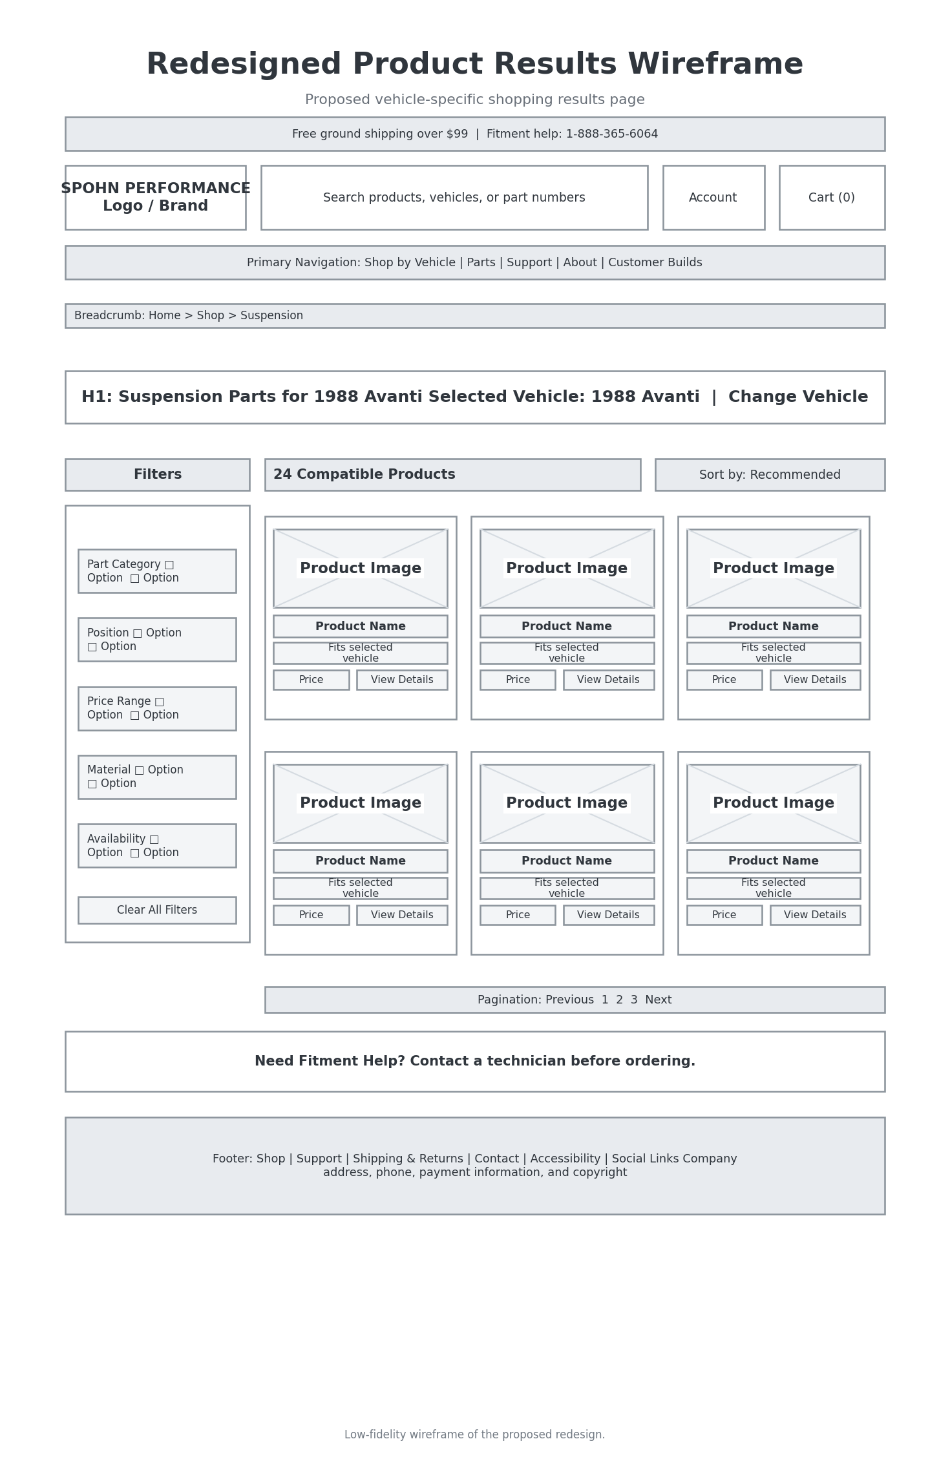
Figure 5. Proposed vehicle-specific product results wireframe.

Redesigned Product Detail Page
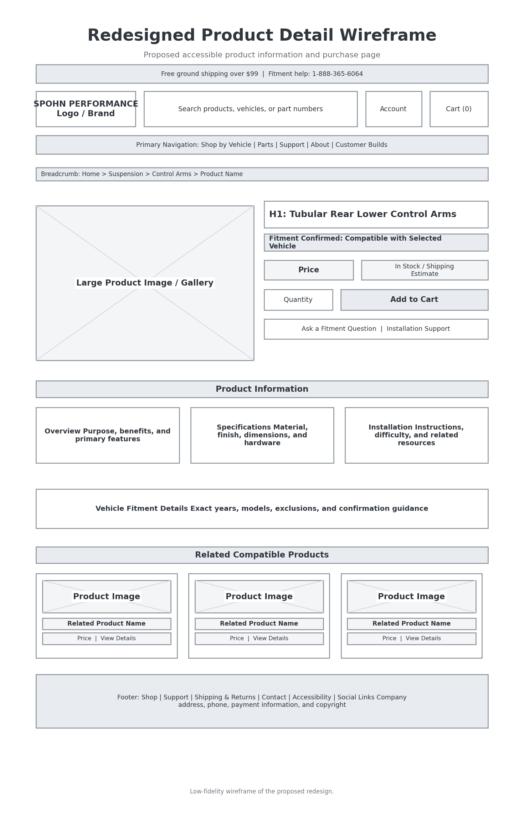
Figure 6. Proposed product detail page wireframe.

Persona Profiles (Updated from part-2)
Persona 1: Peter Gailitis, age 21, is a college student and music producer who has restored a family 1988 Avanti McKelly. He is comfortable with technology overall, but not with confusing ecommerce structures. He visits Spohn Performance looking for suspension and chassis parts, but wants to quickly understand whether a part is relevant, what it costs, and who to contact if fitment is uncertain. He values clear search, visible technical support, and images that help him trust the company.
Persona 2: Marcus Delaney, age 34, is a fictional weekend car-builder who owns an orange Camaro street build and shops for handling upgrades after work. Marcus already understands basic performance terminology, but he still expects a modern shopping flow. He wants to filter by vehicle family, compare similar products, and jump from customer builds to product pages without being buried in old-fashioned navigation. If a site feels suspicious, cluttered, or hard to use, he will leave rather than work around it.

Justification for Persona Choice
These personas were chosen because they represent two realistic types of users the redesign must support. Peter represents the restoration-oriented shopper who may not know every part name but needs reassurance, guidance, and easy access to support. Marcus represents the experienced enthusiast who already knows roughly what he wants, but will be deterred by friction, clutter, or vague information. Designing for both users helped shape the final direction of the redesign: clearer product cards, a prominent vehicle path, visible support resources, and a much stronger customer-cars section.

Coding and Posting of the Redesigned Site
For the coded prototype, I created a multi-page HTML and CSS redesign and expanded it with JavaScript for accessibility-focused interaction. The final prototype includes four pages: a redesigned homepage, a product-results page, a technical-support page, and a customer-cars page. This exceeds the minimum requirement of coding and posting two pages, and it also satisfies the extra-credit goal of coding a third page. The support page includes a fully labeled form with inline validation messages and an error summary, while the customer-cars page includes an accessible multimedia slideshow with captions and a transcript. In addition, the support page uses ARIA-supported collapsible FAQ sections to make rich interactive content accessible from a keyboard and screen reader perspective.

Final Project Final Version

Site Owner Contact Attempt Report
I was not able to obtain an interview with Spohn Performance despite planning to do so in the proposal. The company site identifies Steven J. Spohn and the Spohn family as the owners and operators, and the official contact page provides phone numbers, address information, and support links, so I attempted to use the available contact paths as part of the project process. However, I did not receive a reply in time for the course deadline. Rather than fabricate an owner interview, (like I did for the interview-assignment) I am documenting that limitation directly because it also supports one of my central findings about the current site: customer communication is not especially clear or confidence-inspiring.
The current live site contains contact information, but important tasks are not organized around user goals. For example, there is a page for contact information and a separate support center, but the path to help is not integrated into the shopping experience in a way that feels modern or transparent. A customer can sign in to an account, but the site still directs users to email or call for order-status questions rather than providing a more visible dashboard or clearly explained self-service workflow. This disconnect became part of the diagnosis for the redesign. Even though the company appears legitimate and established, the interface does not communicate that trust efficiently.
Because I could not interview a Spohn representative, I relied on the public content of the current site to identify likely business goals. Those goals appear to include selling suspension and chassis parts, promoting the company’s manufacturing quality, highlighting customer builds, and steering users toward technical support when needed. The redesign therefore tries to support those goals more directly: products are easier to scan, the support phone number is visible in the header, order-help language is easier to find, and customer builds are promoted as a meaningful source of trust rather than hidden navigation clutter.
I also think the lack of response matters rhetorically. If a new customer already feels skeptical because the interface looks outdated, any delay or lack of response from the company can amplify that skepticism. This does not necessarily mean the company has poor products. In fact, part of the reason I chose the site is that Spohn appears to make strong parts for automotive applications. The problem is that the user-experience can undercut the credibility of that product quality. Therefore, even without a completed owner interview, the failed contact attempt became useful evidence in support of the redesign rationale.

User Interview Report: Jaron
For the required user interview, I interviewed Jaron, a computer science student in his final year at CU Boulder. Jaron also likes cars, so he was a useful participant because he brought both technical awareness and enthusiasm for automotive browsing. I showed him the current Spohn Performance site and then the redesigned pages I created for this project. His immediate reaction was that the redesign was “exponentially better,” mainly because the new pages made important features visible instead of burying them under noise.
One of the most interesting comments Jaron made was that, after reviewing my redesigned pages, he realized there were features on the original site that he did not even know existed. That alone says a lot about the current information architecture. If a user can spend time on a site and still not realize what sections are available, then the navigation is not doing its job. Jaron agreed that the current site seems to be reaching for a retro aesthetic, but he also pointed out that there is a difference between retro style and outdated usability. He felt the site could absolutely preserve a performance-oriented, old-school vibe while still presenting information in a modern and accessible way. (Though I admit that was not what my updated-design illustrates)
Jaron was especially bothered by the way the live site handles account and order-status information. He noticed that users can sign in, but there is no strong or obvious system for checking past orders or monitoring order progress. Instead, the site largely pushes users toward emailing or calling if they have a question. He interpreted that as a sign that the account experience is underdeveloped and that the company is placing too much burden on the customer. In the redesign, I responded to that feedback by giving order help its own clear section on the support page and by making support pathways more visible in both the header and the footer.
Another point Jaron emphasized was speed of use. Because he already had certain parts in mind, he tried to imagine the quickest path from interest to purchase. On the original site, he said the amount of clutter and the long lists of categories made it hard to orient himself. On the redesigned version, he was able to move through the product results much faster because each listing contained a readable title, a real image, a price, a fitment label, and a direct support action. He said that even though the redesign was only a prototype, it felt more trustworthy because it explained what the user was looking at.
At the end of the interview, Jaron said that the current site’s difficulty would be enough to deter him from using the company altogether. Even after confirming through outside discussion forums that the company is real, he still felt the interface created too much suspicion and friction. He also pointed out a small but telling detail: some labels on the current site still say “Spohn 2024,” which suggests the interface is not being maintained carefully. In contrast, the redesign updates the copyright year automatically and makes key content easier to discover. Overall, Jaron’s feedback reinforced the main project thesis: the issue is not that Spohn lacks useful content, but that its current presentation prevents users from accessing that value efficiently and confidently.

Final Reflective Report on the Redesign
This redesign began with a simple observation: Spohn Performance appears to sell legitimate and often well-regarded performance parts, but the current website makes the company harder to trust and harder to use than it needs to be. The homepage is crowded, visually noisy, and overloaded with small navigation targets, low-level category lists, and mixed promotional elements. Important features such as support resources, product browsing, customer builds, and account-related tasks exist, but they are not presented in a way that supports efficient use. My goal for the redesign was not to erase the site’s performance-oriented personality, but to preserve its automotive identity while removing barriers that create confusion, frustration, and skepticism. I will admit that in doing so, the site did lose its retro-look, but more than made up for it in terms of usability.
The most important change I made was restructuring the information hierarchy. Instead of forcing users to confront a dense wall of categories and competing visuals, the redesigned homepage immediately answers the question, “What can I do here?” Users can browse products, shop by vehicle, contact support, or explore customer cars. This reorganization reflects both usability and accessibility goals. It helps sighted users scan more quickly, and it also supports assistive-technology users by creating a cleaner heading structure, clearer landmarks, and fewer ambiguous interactions. The redesign therefore addresses problems raised in the heuristic evaluation, the WAVE review, and the user feedback.
A second major change was the redesign of product presentation. In the original site, products can be difficult to compare because the interface emphasizes outdated layouts rather than scannable information blocks. In the redesign, each product card groups together a real product image, the product name, fitment information, a short description, a SKU, and a visible price. I used current public Spohn product data so that the prototype would not rely on generic placeholders. This matters because it shows that better usability does not require removing the company’s real inventory or product specificity; it simply requires presenting that information with more clarity.
Technical support was another critical area. The current site contains contact information, but the user must work to understand which phone number to call, when support is available, or how to ask a fitment question. The redesigned support page brings official contact information to the top, separates technical support from order-only communication, and adds a clearly labeled accessible form. That form was also designed for extra-credit accessibility goals: every field has a label, required fields are announced visually and semantically, validation produces inline messages, and an error summary appears at the top if the user submits incomplete information. This is the kind of practical accessibility work that directly improves usability for many users, including people with visual, motor, and cognitive challenges.
I also added ARIA-supported accordion sections for frequently asked questions. This serves two purposes. First, it reduces page clutter by allowing users to reveal only the help content they need. Second, it demonstrates how interactive content can remain accessible when buttons, states, and controlled regions are properly labeled. The customer-cars page extends the redesign in another direction: trust and engagement. On the current site, customer builds exist but do not function as a strong persuasive feature. In the redesign, they become a primary destination with stronger photography, short descriptive summaries, and clear links between inspiration and shopping. I used the supplied Avanti and Camaro images to show how this could work in practice.
For extra credit, I also included an accessible multimedia element: a short HTML5 video slideshow built from Avanti restoration images I had. The slideshow includes controls, captions, and a transcript. I chose this feature because multimedia often becomes inaccessible when designers treat it as decoration instead of useful information. By adding captions and a transcript, the prototype shows that even a simple media element can be made much more inclusive.
The user interview with Jaron helped confirm that the redesign was moving in the right direction. His strongest responses were about discoverability, trust, and efficiency. He felt the live site hid features and created enough friction that he might avoid the company entirely, even if its products were good. That reaction aligns with my own experience using the site while researching parts for the Avanti project. The interface creates doubt, not because the company is necessarily untrustworthy, but because the site does not communicate competence in a contemporary way.
Overall, the redesign demonstrates that Spohn Performance could maintain its ‘niche’ automotive personality without sacrificing clarity or accessibility. A better hierarchy, more readable product listings, visible support, stronger account and order-help cues, and a more engaging customer-cars section all help the site serve both users and the business more effectively. If I continued the project, I would expand the account dashboard, add a more complete product-detail page, and test the prototype with additional users. Even in its current form, however, the redesign shows how usability, accessibility, and brand identity can work together rather than against one another.

Prototype Files Included
The final folder includes the following files: index.html, products.html, support.html, customer-cars.html, style.css, script.js, local image assets, and accessible multimedia file with captions. These files collectively document the redesign and demonstrate the final coded prototype. (via GitHub)

GitHub Repo: https://github.com/obsanity-live/ATLS3519-640F/tree/ff820f6eb7e03c4e46324b91a9573d6bdfd91bce/ATLS3519-640F%20FINAL%20PROJECT%20%7C%20Gailitis

